**7.1 :Measures initiated by the Institution for the Promotion of Gender Equity**

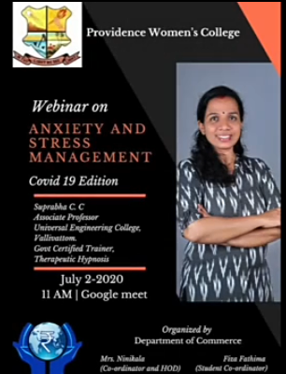 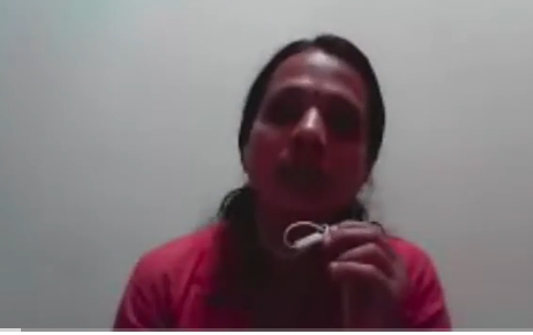

“**Anxiety & Stress Management in Covid-19 Edition"**

On 2nd July 2020, Department of Commerce organized a Webinar on the topic “**Anxiety & Stress Management in Covid-19 Edition"**. The resource person of the session was Ms.Suprabha C.C, Associate professor& Govt.certified trainer, Universal Engineering college, Vallivattom. The webinar was conducted to provide students and teachers measures to overcome the stress, tension and anxiety created due to the sudden shift of classes from offline to online during Covid 19 Pandemic. The resource person shared many thoughts on Yoga, Meditation, and Breathing exercise and also conducted counseling for students through Google meet.Later the videos of the webinar were launched in the YouTube channel ‘*calypso*’.

A Webinar on Gender, Sexuality and Cultural Practices by Dr. Navaneetha Mokkil,Assistant Professor, Jawaharlal Nehra University was conducted via GOOGLE MEET on **6 July 2020, by the Department of English.** All the students and teachers of the department attended the talk which dealt with an indepth discussion of cultural practices that promote sexism.

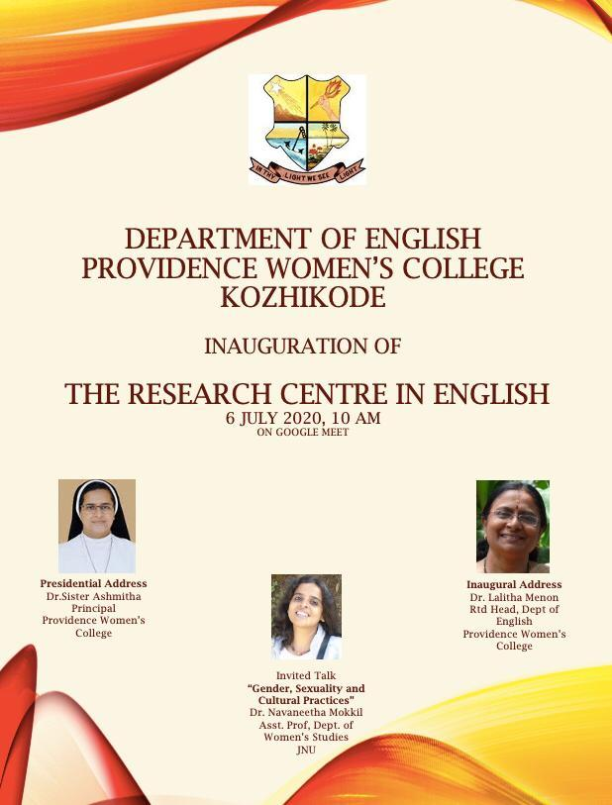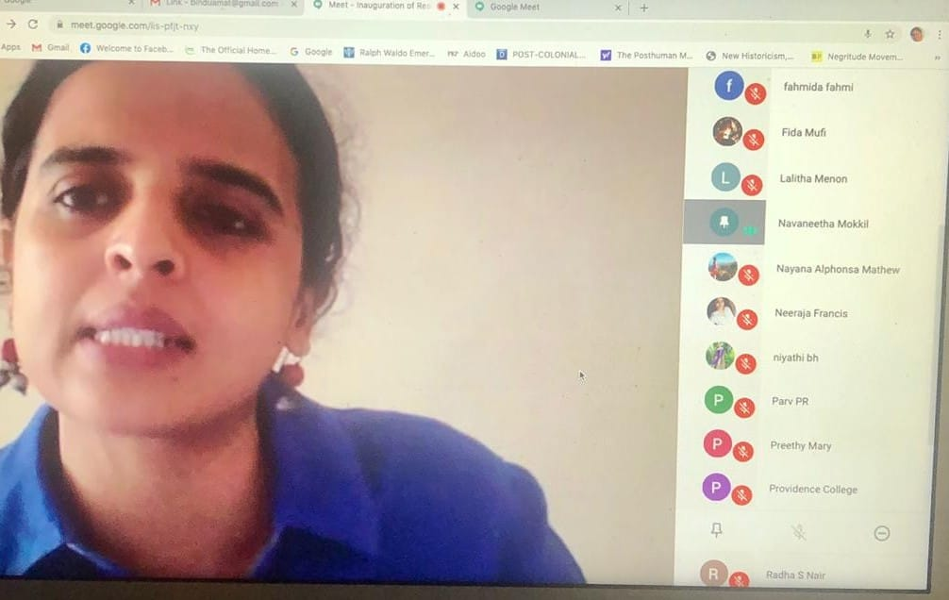

A Class on the CLASS ON IMPORTANCE OF HORMONES & BALANCED DIET was conducted by DEPT OF ZOOLOGY by DR. SHANTY GEORGE SHAH, an Endocrinologist and Diabetician of London, UK. We conducted an International Webinar on the topic, “**THE RHYTHM OF LIFE: A Beautiful Thyroid Gland”.** The programme was conducted on 18th September, 2020.

|  |  |
| --- | --- |
|  |  |

On 21 sept 2020, Departmnet of Zoology organized AWARENESS ON WOMEN HEALTH PROGRAMME titled **Memories Do Matter: Fight Against Alzhiemers**".The speaker was **DR. PAUL J ALAPPAT**, fellow of European Board of Neurology & Neurologist at Aster MIMS Calicut. 80 students participated.

|  |  |
| --- | --- |
|  |  |

On 30 th October, The Department of Computer Science conducted a Webinar on the topic “Women empowerment through technology in association with Talrop” for the entire students of the Department. The webinar was conducted by the company Talrop. The webinar was held on 30th October 2020 through Google Meet.Mr. Shameer Khan, Co-founder and CEO, Talrop and Reem Khan, Startup Head, BDO,Talrop was the Resource person and the lead of the program. The webinar began at 11:30AM in the presence of all faculties of Computer Science Department .A detailed explanation regarding women empowerment through technology was given to the students by the resource person. Technology plays a major role in today’s lifestyle and it bridges the growing gender disparity, by giving women an opportunity to learn about technology and new things. The session was highly informative and helped everyone to imbibe knowledge about women empowerment through technology.

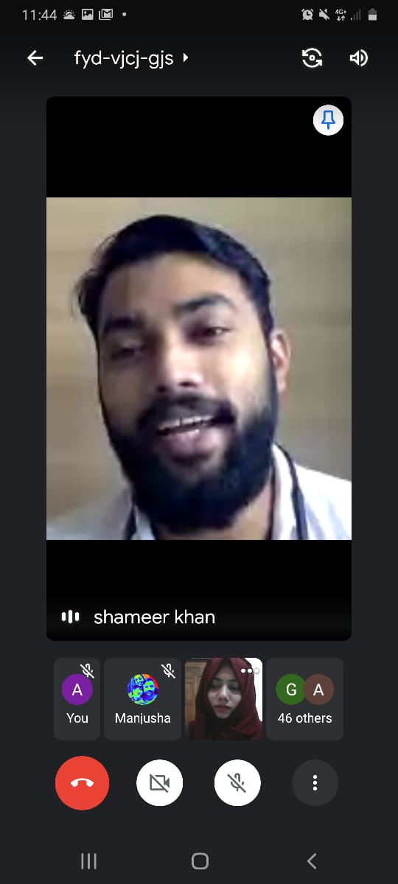

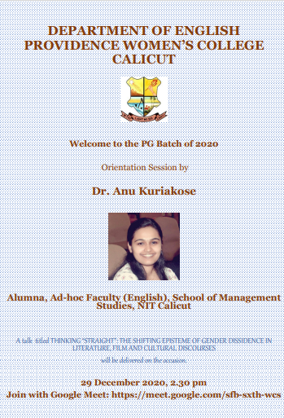 A Webinar on Thinking Straight: The Shifting Episteme of Gender Dissidence in Literature, Film and Cultural Discourses by Dr. Anu Kuriakose, NIT, Calicut was conducted on Google Meet on **29 DEC 2020**. Link of talk: <https://youtu.be/5DB4cdYQoog>.

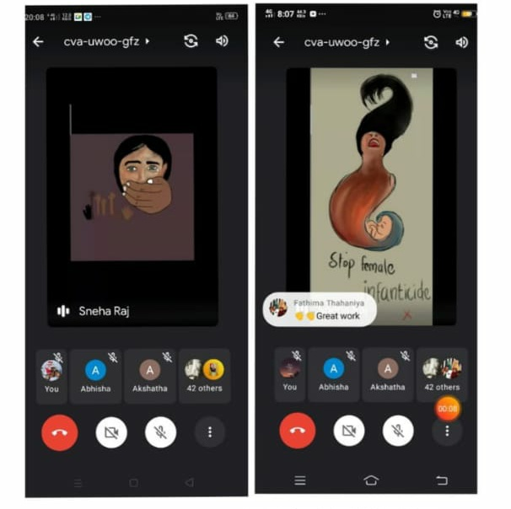

On January 24, 2021 the department of psychology in connection with national girl child day conducted a talk by the head of the department Dr. Lijiya Manju, which focused on the challenges that girls faced in Indian society due to gender bias .Followed by the talk, the theme of the event was also highlighted through a thoughtful message by a first year student which gave awareness about education, equality and the need for giving an  abundance of love to the girl child to make her confident and headstrong.

On Feb 11-Feb 14, 2021 , the NSS volunteers took part in the Gender Conference which was based on the theme of Women empowerment and Transgender Inclusion at International Gender Conference at Gender Park, Calicut

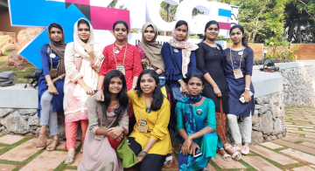

de

|  |  |
| --- | --- |
|  | C:\Users\VivoBooK\OneDrive\Desktop\photo-webinar.png |

partment attended the talk.The link of talk:

Department of Travel and Tourism conducted a Program-A debate on “Time to fight for your right”, on 8 March 2021 @G.meet-10am. It was an one hour program to share their views on women’s right and equality in the society .They concluded the debate by talking about the importance of being self dependent and protecting their rights to live in the society

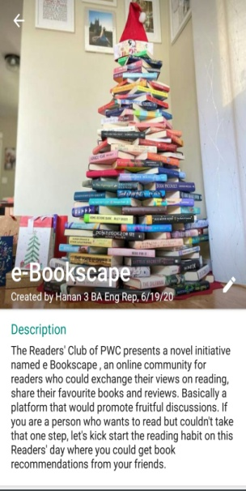The Readers' Club of Providence Women's College decided to celebrate the International Women's Month by honouring powerful women authors, their works and female characters in literature by releasing a series of videos on YouTube through the official channel of the Dept of English.International Women’s Day is a UnitedNations- sanctioned global holiday. It celebrates women’s contributions to society, raises awareness about the fight for gender parity, and inspires support for organizations that help women globally. The e-bookscape , the readers watsapp group staunchily believes that , collectively, we can all help create an inclusive world because from challenge comes change, so we should  choose to challenge.

LINKS OF THE YOUTUBE VIDEOS:

<https://youtu.be/PcPCyocSjxI>

<https://youtu.be/UFcaZe8Wshw>

A programme was conducted for the whole college as part of celebrating Women’s Day, on 8 March. All the staff and students participated in this programme.On March 6th and March 8th, the NSS volunteers of Providence Women's College conducted a quiz competition named virago intercollegiate quiz competition related to women's day celebration. For this quiz competition, some of the NSS volunteers organised the program. Registration for this quiz competition was started 4th March 2021 through Google form.First level of this quiz competition  conducted online via google meet and selected 12 participants are eligible for final level of the quiz. 10 students attended the quiz competition at Providence women's college Malaparamba. Cash prize and certificate were awarded by the 1st, 2nd and 3rd level of winners. Every participants got their participant certificate

Another remarkable achievement was that, Chithrangada of 2nd B.A.English edited and compiled a blog titled ‘mallugirlstories’ , as part of NSS where women could speak out openly about their experiences.The blog was released by our principal on 8 March, Women’s Day. Link: <https://mallugirlstories.wordpress.com/blog/>

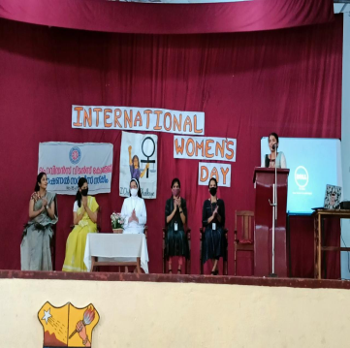

**As part of Women’s Day, PROVI NEW WAVE,t**he film club of the department celebrated the passion and resilience of the female gender by screening inspiring women oriented movies because International Women's Day is the perfect opportunity to celebrate and acknowledge not just the women in our life, but women all over the world.It compiled a list of inspiring films that celebrate the passion and resilience of the female gender and the selection of the movies catered to everyone's tastes.Link of channel: <https://t.me/joinchat/RdZmHk_1Ht3fpk4k>

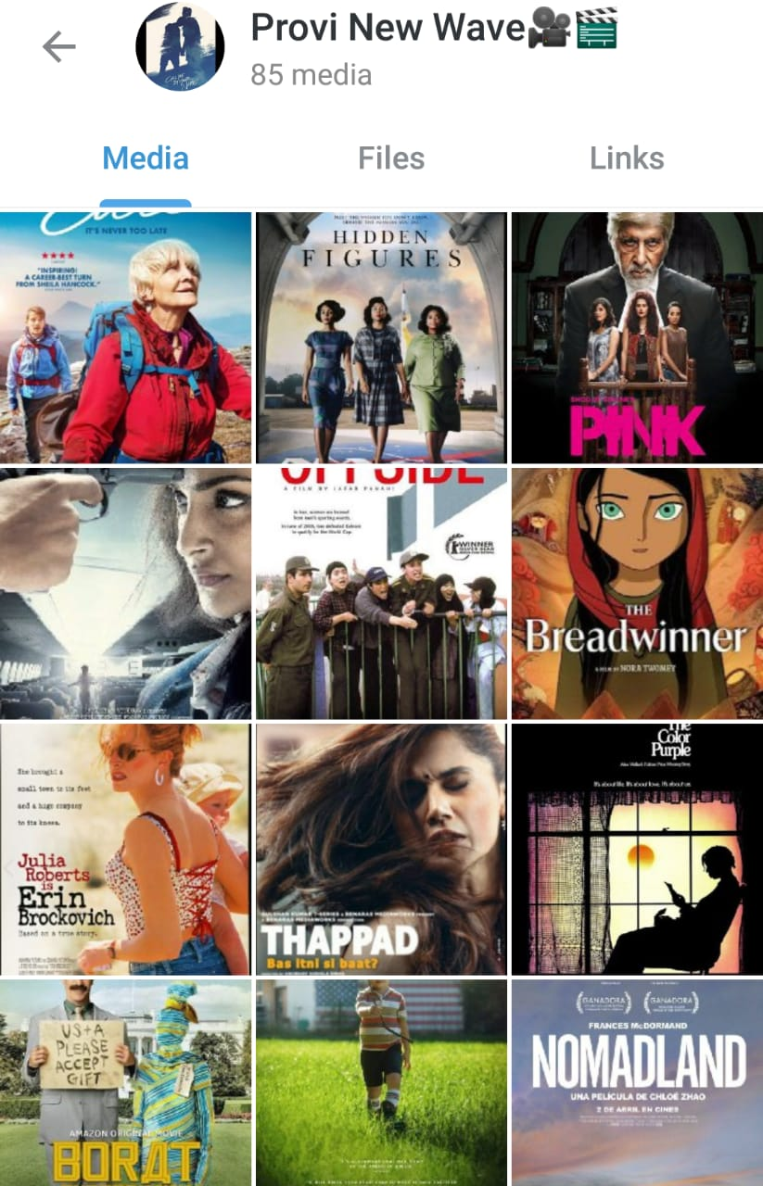

Department of Business Administration conducted a webinar on Transgender community social and inclusive approach which was conducted on 3rd april, 2021 [saturday]The Speaker was Dr. Saranya T.S., Psychologist,Karunya psychological centre,Vadakara. DATE: 3rd April, 2021,TIME: 10am ,PLATFORM: GOOGLE MEET

The Department of Business Administration of Providence Women’s College, Calicut conducted a webinar on “Transgender Social and Inclusive Approach” for students inside as well as outside the campus, teachers, faculties and for housewives. There were 133 participants in total out of which 125 were college students and the rest were school students and employees. The speaker was Dr. Saranya T.S. who completed her PG and PhD from Pondicherry Central University. She has also published a book on mental health of adolescents published by Lulu publishers, USA. Ms. Saranya also around 20 articles in both National and International journals. She is also known as the ambassador of Surakshitha Koumaram project launched by Malayala Manorama.

The course content delivered in the webinar was as follows:

The webinar was how to protect the transgenders and also see them as one among us. The main highlight were, “ transgenders are also humans. They are one among us. It is just that transgender are considered to be a third gender. They were born like that and it isn’t their fault that they became like that. So DO NOT AVOID OR CRITICISE THEM’.The topic was something to be taught psychologically. Transgender’s are also humans and they also have the right to be treated equally in a society. It isn’t their fault that they were born like that, or neither they did any mistake to be born as that. There are many superstitions and myths related to transgender’s. Dr. Saranya started her session by saying those superstitions and myths. Many of those were believed by most of us and came to know the reality after the class. Transgenders are humans and not any aliens or something else. They too have all rights and freedom that we have. Many of us say that why cant these people do some work for their living? The answer to this question lies among us. Soon after Dr. Saranya’s speech there was an amazing interactive time.

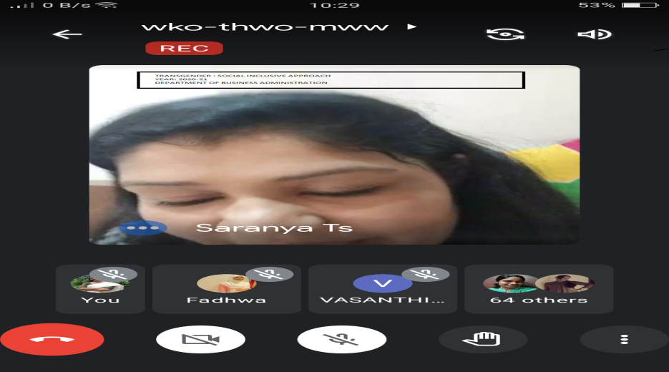

|  |  |
| --- | --- |
|  | C:\Users\USER\Desktop\NAAC\subcommittee work\screen shot for motivating young girls (1) - bba dept.png |

On 22 April 2021, The Department of Business Administration conducted webinar on Motivating Young Girls To Recognize Respect And Care For Elders for the students, scholars and teaching faculties from *12 pm - 1 pm.* The resource person was **Ms. Nadha Ashraf** (3rd year student Department of Business Administration) There were totally 56 participants in webinar, out of them 45 were students from various schools and 10 other from various departments of our college and institutions**. *Ms. Nadha Ashraf****,* 3rd year student of BBA department is an excellent student and also a promising motivating speaker.

*The course content derived in the webinar is as follows:*

Respecting elders, Recognizing and accepting

Not to be egoistic, acknowledging and accepting the past/old.

Take chances - Reading makes you better, experience makes you much better

Have a push - make sure to have support or push

Pray for the people you love

help yourself to overcome selfishness

Be good listener

On June 6th ,the units of NSS of Providence conducted a CLASS ON MENSTRUAL HYGEINE IN COLLBORATION WITH CHILDREN’S HOME FOR GIRLS, VELLIMADUKUNNU menstrual hygiene by Chief Guest DR MEENA DEVAYANI. Name Of The Programme was *Glorify Your Flow(*<https://meet.google.com/xyx-cwnm-axx>)

|  |  |
| --- | --- |
| C:\Users\USER\Downloads\WhatsApp Image 2021-06-05 at 9.52.25 PM.jpeg | E:\NSS\NSS MAY 2021-\PHOTOS\menstrual hygeine day.jpeg |

**PRIDE MONTH CELEBRATIONS JUNE 2021 by Department of English:**PAINTING COMPETITIONS ,DIGITAL ART COMPETITIONS ,HAIKU COMPETITIONS were conducted for the whole college, to observe and celebrate Pride Month and to create awareness about socially inclusive approach

|  |  |  |
| --- | --- | --- |
| C:\Users\USER\Desktop\NAAC\photos\PHOTOS\pride month 2021 (3).jpeg | C:\Users\USER\Desktop\NAAC\photos\PHOTOS\pride month 2021 (2).jpeg | C:\Users\USER\Desktop\NAAC\photos\PHOTOS\pride month 2021 (1).jpeg |

On 11 June 2021 ,NSS volunteers Hilma and Vismaya Sajeevan ,conducted an interview with Delisha Davis ,a Commerce Post graduate (who works as a truck driver )via zoom call.

|  |  |
| --- | --- |
| YOUTUBE VIDEO RELEASE | <https://youtu.be/ZKs8vfZJnw8> |

As part of the National Reading Day celebration , Department of Physics, Providence Women’s College organized a talk on ‘female characters in literature and society’. The speaker of the session was Dr Sr Ashmitha , Principal Providence Women’s College. It was held on 19 th June 2021 from 10 a.m. to 11 a.m. The programme was hosted by Nada Ayisha and the event began with a prayer song by Gayathri Nambiar followed by the welcome speech of Sreereshmi. The

presidential address was delivered by Dr A Sobha , Head of the Department. Resource person depicted the importance of reading in detail and the programme ended with the vote of thanks by Archana S Nair.

• In order to mark the importance of the day , an electronic library SCI-FI ARCHIVE to access and

share all the scientific and fictional ,academic and own academic books was inaugurated by Dr

Sr Ashmitha via Google meet platform on 19 th June 2021 at 10:30 a.m.

• Secondly, two videos uploaded in the YouTube and in the Instagram page of Physics department

@bhauthik\_p6 . The first video was performed by Nada Ayisha on ‘ P N Panicker – The Father of

Library Movement in Kerala’ and the second was done by Anamika S on ‘The Importance of

Reading’.

• Besides, a Vocabulary Game ‘WORD SALAD’ was conducted on 19 th June 2021 at 7:30 p.m. It was conducted by forming a WhatsApp group with the participants. Having two rounds, a total of 57

students participated in the game and the result was announced by 9:30 p.m. with Sandra R

Thomas, 3 rd Year English as the winner.

|  |  |  |
| --- | --- | --- |
|  |  |  |

**READING WEEK CELEBRATIONS were conducted by Department of English during the week of JUNE 19-25, 2021.** BOOK REVIEW COMPETITIONS ,LETTER WRITING COMPETITIONS were conducted for the whole college, to observe and celebrate Reading week. The theme for the competitions was Gender Equity.

|  |  |
| --- | --- |
| **C:\Users\USER\Desktop\NAAC\photos\PHOTOS\readers week (1).jpeg** | **C:\Users\USER\Desktop\NAAC\photos\PHOTOS\readers week (2).jpeg** |

Gender Sensitization was organized in the Zoology dept on **On Transitioning & Gender Identity** was conducted by **Dr. A.P.M. Mohammed Rafeeque**, former Head dept of zoology MCC on 21st June, 2021.95 students participated in this programme.

|  |  |
| --- | --- |
|  |  |

|  |  |
| --- | --- |
| **C:\Users\USER\Downloads\transgender-photo2  -   7.1.1 - travel tourism.jpg** | **C:\Users\USER\Downloads\Photo3-Anuradha-transgender-7.1.1 - travel tourism.png** |

On June 24,2021, Department of Travel and TourismManagement, conducted a program named “TRANSITION IN GENDER” as part ofpride month. It was a talk on the same topic, Transition in Gender itself. There were two guests for the program, Dr. V.S. Priya and Anuradha Govindan. Dr. Priya is kerala’s first transgender doctor, currently she is working as Ayurveda Physician at Sitaram Hospital, Thrissur. Anuradha Govindan her native place is Kannur, but sheis currently residing at Kozhikode. Ms. Anuradha is a makeup artist by profession.The guests started to speak about their lives, how theystruggled and the changes happened to their bodies and to their lives. How content they feel and how complete they are in their lives now. The students and as well as the teachers got to understand about the difference between what sexuality is, what sexual

orientation is. The main motive of this program was to understand that each and every one is equaland to respect and honor every person no matter what the difference is.This pogram helps to

understand that no one is different in terms of anything especially in terms of sexuality or

sexual orientation because that is the main difference which we are showing to those

people who belong to the LGBTQ+ community.

As a part of pride month celebration ,the NSS volunteers of Providence Women’s  College conducted a program “BREAKING STEREOTYPES”.It was conducted on  June 26 th by Resource Person Miss Heidi Saadiya, the First transgender podcast  journalist in kerala and you tube influencer. Due to the Covid pandemic the program was  conducted via Google Meet.Most of the NSS volunteers and Programe Officers  attended the program .It was a very informative section on the topic LGBTQ. On june 24th 2020 ,a podcast was released on the topic LGBTQ by 2 volunteers Link of the podcast: <https://anchor.fm/kaathodukaathoram/episodes/Pride-Month-e13dc50>

|  |  |
| --- | --- |
| C:\Users\USER\Downloads\WhatsApp Image 2021-06-26 at 9.38.45 AM.jpeg | E:\NSS\NSS MAY 2021-\PHOTOS\pride month.png |

**On 25 JUNE 2021,** Department of Botany conducted a webinar cum interactive session on Gender sensitization vs Gender equity . Advocate Noorbeena Rasheed, Lawyer ,social activist, former member of the Kerala Women’s Commission was the chief guest. She led the session on gender equity. The next session was handled by Dr. PN Ajitha, Gynecologist and elected representative to the Kozhikode Municipal Corporation. The programme was conducted online. The session started at 4.30 pm and it came to close at 7.30 pm. 94 students attended the programme.

|  |  |
| --- | --- |
| **C:\Users\USER\Desktop\NAAC\subcommittee work\BOTANY - Aadhi Gender sensitization - Deena Meria Jose (1).jpg** | **C:\Users\USER\Desktop\NAAC\subcommittee work\BOTANY - Aadhi - Gender sensitisation - Deena Meria Jose.jpg** |

An inter departmental essay writing competition was conducted by the Department of History, as part of the observation of International Widows’ Day on 25/06/2021. Six students participated in the competition. The winner of the competition is Sneha Martin of III B.Com

As part of International Day against Drug Abuse and Illicit Trafficking, the Department of Computer Science conducted an awareness program for the students by Resource person Dr. Sajith.K. who is currently working as Professor, Department of Pharmacology JDT Islam College on 26/06/2020. Talk was given to UG and PG students. A total of 65 students were present for talk. The talk was

mainly done to bring an awareness amongst students against drug abuse and illicit trafficking. Students really found the talk as an informative.

|  |  |
| --- | --- |
| https://lh5.googleusercontent.com/P_pXOBXO9IKY9iB6pobV6-jsto1buus_Iv8KKmakXH0xdPBPPstHrgEmzWaJI8aga8Ycab0L3cgngBYRvQAddD_m7mglM55VflGNIo0_FUnWFonTEpTjurrR9Cvi0JwpZwoPKIYg | C:\Users\NODE-6\Desktop\NAAC\criteria 7 new\7.1.1\anti 2021_screenshot.png |

**WEBINAR ON GENDER EQUITY WITH SPECIAL REFERENCE TO THE REPRESENTATION OF WOMEN, MARRIAGE AND DOMESTIC VIOLENCE IN MALAYALAM CINEMA** The Film Club of Department of English conducted a talk on gender equity with special reference to the representation of women, marriage and domestic violence in Malayalam cinema with DR.K.R. RAGI as the chief guest on 30 JUNE 2021; 7 PM via Google meet.

|  |  |
| --- | --- |
| C:\Users\USER\Desktop\NAAC\photos\BROCHURES\dr ragi talk.jpeg | C:\Users\USER\Desktop\NAAC\photos\PHOTOS\dr. ragi talk.jpeg |

On 30 JUNE 2021, the Department of History conducted a programme with Vaiga Subramaniyam, a Transgender activist, model and motivational speaker , sensitized the students on the problems faced by the trans-genders and the need to accommodate them also in the mainstream. Faculty of other departments, Second and final year students of History and NCC Cadets of other departments also participated in the webinar.

'In India sex education stops when the teacher skips the reproductive system in class'. This quote tells us the situation of Indian children. On July 3rd a session by Dr.Shifana,gynecologist was conducted under the topic 'Sex Ed'. In our society this topic itself is considered shameful. And if any child talks about it, she/ he is labelled as a disgrace. The program was really wonderful and useful. The session cleared a lot of our doubts and misconceptions and provided awareness . The session lasted almost 2 and a half hours. <https://meet.google.com/bbh-iseb-fdb>

|  |  |
| --- | --- |
| C:\Users\USER\Downloads\WhatsApp Image 2021-07-03 at 9.13.59 AM.jpeg | E:\NSS\NSS MAY 2021-\PHOTOS\sex education 1.jpeg |

On July 7, 2021, the department of History conducted an interdepartmental video making competition Pennayal Ponnu Veno was conducted in the wake of frequent dowry deaths in Kerala. Winners of the competition are Shana Parvin, Drishya M K , II History, Hilma Salam , II History

A motivational talk for the students of Department of Computer Science was conducted on 12/07/2021 by Resource person Dr. Pratibha P., who is currently working as Assistant Professor ,Department of English, Providence women’s college. Talk was given to UG and PG students. A total of 76 students were present for talk. The talk focused on motivating our students for motivating our students, students really interacted with resource person and made their doubts cleared regarding life skills, language perspectives and various other areas. In the talk she also spoke on becoming strong enough to stand on your own feet, earning a job, importance of having a calm mind and patience.

|  |  |
| --- | --- |
| https://lh5.googleusercontent.com/6j_Wat67V14O-D-U7M6AA9j12avXzC8oCj2_briU7yPfSsW0pRxS3D89Ko0BwcXHZ1UwHTwW5XDCXR6vJEzlt_u5mQZWijFuWViRxSmNvUzXLy6rCpLeYpF1aGVY-QpizcNt1MOs |  |

On 15 July 2021, as part of GENDER SENSITISATION, a podcast was uploaded by NSS Volunteers on the NSS PODCAST on July 15th 2021 as part of the World Population day.The movie review talks about how the choices and dreams of a woman should be given priority and significance. The link is <https://anchor.fm/kaathodukaathoram/episodes/SARAS-Movie-Review-e14fkpt>

On 24 JULY 2021, a GENDER AWARENESS PROGRAMME IN COLLABORATION WITH Women and Child Development Cell was conducted by NSS. In this pandemic situation of Covid-19,the volunteers of Providence Women's College NSS units 15 &116, conducted an online survey from 16th July to 20th July with the intention of knowing that how many people around us have been the victims of sex abuse. The survey focused on the age group 18 and above including males and females and others. We got nearly 317 responses to the survey conducted through Google form, which helps us to know the hidden truth. All the action figure is likely much higher than will be many who don't speak out with fear. The fact is that about 2 in 10 girls under the age of 20 have been forced to engage in sex or perform other sexual acts. This survey report was presented before the gender awareness programme session conducted by Department of Women and Child Development.The session was blessed with the presence of the chief guest MR. Abdul Bari, DWCDO Kozhikode and resource person Adv Abija P A who spread colour to the young minds of girls. Adv Abija P A shared a lot about women and child development schemes and also explained about the immoral traffic mafia. The meeting was hosted by Ms. Joicy from Department of Women and Child Development.

|  |  |  |  |  |  |  |
| --- | --- | --- | --- | --- | --- | --- |
| C:\Users\USER\Downloads\WhatsApp Image 2021-07-22 at 8.41.29 PM.jpeg | | E:\NSS\NSS MAY 2021-\PHOTOS\GENDER AWARENESS 24 JULY (3).jpeg | | | <https://www.instagram.com/reel/CR0mVRjgdfR/?utm_medium=share_sheet>  KANAL: A dance video  Providence womens college NSS unit no 15&116  In collaboration with  Women and child development cell | |
|  |  | |  | |  |  | |

On 27 JULY 2021, as part of Trangender Inclusion Awareness,a podcast as a tribute to Ananya Kumari Alex the first transgender RJ was released by NSS.The Podcast was uploaded on 27th July and is an eye opener on today's educational system. Ananya Alex Kumari had done a sex reassignment surgery which was a failure, which led to her suicide.The podcast mentioned her experiences with today's manipulative medical senario. Link of the podcast: <https://anchor.fm/kaathodukaathoram/episodes/Remembering-Ananya-e15362o>

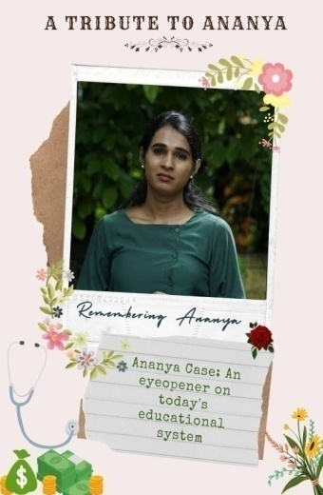  
 Breast feeding week was observed on 1 st August 2021in the online mode by the Department of Botany. An awareness talk on the topic ‘normalise breast feeding in public and stop sexualising breast’ was held as a part of the programme. Ms. Rini Raveendran, Sub editor, Mathrubhoomi online news was the chief guest. 94 students attended the programme.The zoology department also conducted a programme titled Protect Breast Feeding- A Shared Responsibility by Dr. Smitha D’Couth, Govt. Medical College Hospital Calicut.

|  |  |  |
| --- | --- | --- |
| C:\Users\USER\Desktop\NAAC\subcommittee work\Botany breast feeding vweek screen shot - Deena Meria Jose.jpg |  |  |

An exclusive webinar session was conducted by the department of Mathematics and Statistics on the topic IS IT HARD TO BE A PRAGMATIC WOMEN on 7th of August 2021 at 10:45 am in its endeavors to empower the women of present society. The session was presided over by Dr. Gigy Abraham, former HOD of Dept. of Chemistry, Providence Women’s College. It was a very interactive and informative session. The webinar ended at 12:45 pm.

|  |  |
| --- | --- |
| C:\Users\USER\Downloads\Talk - maths dept.jpg |  |

Women's Equality Day is an annual event observed in the U.S on August 26. It is celebrated in memory of the day when allowing women to vote officially become part of the U.S constitution. It commemorates the passage of 19th amendment. In 1971 U.S congress designated august 26 as women's equality day. Since equality is an important subject in current scenario and women are facing much violence and discrimination, this podcast aims at providing awareness on gender equality.   Link of the podcast: <https://anchor.fm/kaathodukaathoram/episodes/Womens-Equality-Day-e16fk99>.

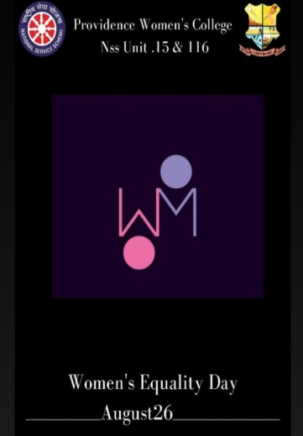

On 28th October 2021, the department of Mathematics and statistics has organised a cartoon competition on the topic ‘Politics and Woman’. Gender sensitization is the basic requirement to understand the sensitive needs of a particular gender. And this cartoon competition helped to bring out the hidden talents of the students and it was great success. There were five entries for this competition and all of them were really good. And the one who was selected as the winner is Avanthika S Anand from 1st year Bsc Mathematics.

|  |  |
| --- | --- |
|  |  |

On 19/11/2021 the Department of Computer Science conducted a gender equity talk for UG students by Dr. Laina. Who is currently working as an Assistant Professor, Department of history, Providence women’s College. A total of 66 students were present for talk.Students really found the talk informative as it focused on gender equity issues, problems faced by them and so on. The talk created an awareness about gender-based things for our students

|  |  |
| --- | --- |
| C:\Users\NODE-6\Downloads\Blue and Pink Bordered Gender Equality Poster.png |  |

**Annual Gender Sensatizion Action Plan**

1. Anti drug Awareness Campaign

2. Stress Management during Covid Pandemic

3. Gender Equity Promotion Programs

4. Honoring Women authors

5. Transgender Inclusive approach

6.  Women's Day Programs

7. Motivating Students to care elderly people

8. Self defense Class

9.Cyber crime and security awareness

10. Sex Education

11. Women’s Rights : Legal and Cultural

\*\*\*\*\*

.